-- Total Loan Applications
select count(id) as total_loan_applications
from bank_loan_data;
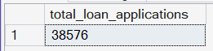

-- MTD Total Loan Applications
select count(id) as MTD_total_loan_applications
from bank_loan_data
where MONTH(issue_date) = 12 and YEAR(issue_date) = 2021;
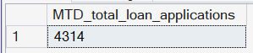

-- PMTD Total Loan Applications
select count(id) as PMTD_total_loan_applications
from bank_loan_data
where MONTH(issue_date) = 11 and YEAR(issue_date) = 2021;
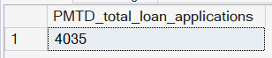

-- Total Funded Amount
select sum(loan_amount) as total_funded_amount
from bank_loan_data;
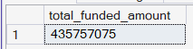

-- MTD Total Funded Amount
select sum(loan_amount) as MTD_total_funded_amount
from bank_loan_data
where month(issue_date) = 12 and year(issue_date) = 2021;
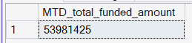

-- PMTD Total Funded Amount
select sum(loan_amount) as PMTD_total_funded_amount
from bank_loan_data
where month(issue_date) = 11 and year(issue_date) = 2021;
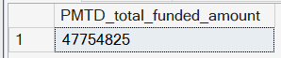

-- Total Amount Received
select sum(total_payment) as total_payment_amount
from bank_loan_data;
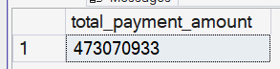

-- MTD Total Amount Received
select sum(total_payment) as MTD_total_payment_amount
from bank_loan_data
where month(issue_date) = 12 and year(issue_date) = 2021;
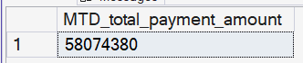

-- PMTD Total Amount Received
select sum(total_payment) as PMTD_total_payment_amount
from bank_loan_data
where month(issue_date) = 11 and year(issue_date) = 2021;
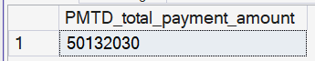

-- Average Interest Rate
select round(avg(int_rate)*100, 2) as total_avg_interest_rate
from bank_loan_data;
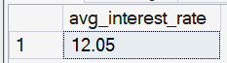

-- MTD Average Interest Rate
select round(avg(int_rate)*100, 2) as MTD_avg_interest_rate
from bank_loan_data
where month(issue_date) = 12 and year(issue_date) = 2021;
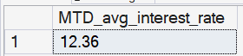

-- PMTD Average Interest Rate
select round(avg(int_rate)*100, 2) as PMTD_avg_interest_rate
from bank_loan_data
where month(issue_date) = 11 and year(issue_date) = 2021;
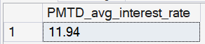

-- Average Debt-to-Income Ratio (DTI)
select round(avg(dti)*100, 2) as Avg_DTI
from bank_loan_data;
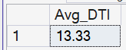

-- MTD Average Debt-to-Income Ratio (DTI)
select round(avg(dti)*100, 2) as MTD_Avg_DTI
from bank_loan_data
where month(issue_date) = 12 and year(issue_date) = 2021;
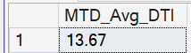

-- PMTD Average Debt-to-Income Ratio (DTI)
select round(avg(dti)*100, 2) as PMTD_Avg_DTI
from bank_loan_data
where month(issue_date) = 11 and year(issue_date) = 2021;
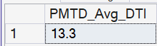

-- to calculate the good loan application percentage
SELECT
cast(round((
SELECT COUNT(*)
FROM bank_loan_data
WHERE loan_status IN ('Fully Paid', 'Current')) * 100.0
/
(SELECT COUNT(*) FROM bank_loan_data), 2) as decimal(4,2))
AS good_loan_percentage;

-- OR

select
cast(ROUND( count(case
when loan_status in ('Fully Paid', 'Current') then id end) * 100.0
/
count(*), 2) as decimal(4,2)) as good_loan_percentage
from bank_loan_data
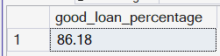

-- to calculate the good loan application
select COUNT(loan_status) as good_loan_applications
from bank_loan_data
where loan_status in ('Fully Paid', 'Current');
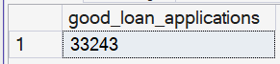
-- to calculate the good loan funded amount
select sum(loan_amount) as good_loan_funded_amount
from bank_loan_data
where loan_status in ('Fully Paid', 'Current');
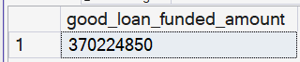

-- to calculate the good loan total received amount
select sum(total_payment) as good_loan_received_amount
from bank_loan_data
where loan_status in ('Fully Paid', 'Current');
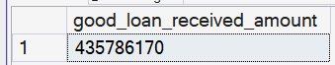

-- to calculate the bad loan application percentage
select
cast(round((select COUNT(*) from bank_loan_data
where loan_status = 'Charged Off')* 100.0
/
(select COUNT(*) from bank_loan_data), 2) as decimal (4,2))
as bad_loan_percentage;

-- OR

select
cast(round(COUNT( case when loan_status = 'Charged Off' then id end)* 100.0
/
count(*), 2) as decimal(4,2)) as good_loan_percentage
from bank_loan_data;
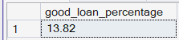

-- to calculate the bad loan application
select COUNT(*) as bad_loan_application
from bank_loan_data
where loan_status = 'Charged Off';
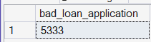

-- to calculate the bad loan funded amount
select sum(loan_amount) AS bad_loan_funded_amount
from bank_loan_data
where loan_status = 'Charged Off';
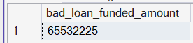

-- to calculate the bad loan total received amount
select sum(total_payment) AS bad_loan_funded_amount
from bank_loan_data
where loan_status = 'Charged Off';
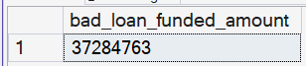

-- Loan Status Grid View
select loan_status,
COUNT(id) as Loan_Count,
SUM(total_payment) as Total_Amount_Received,
sum(loan_amount) as Total_Funded_Amount,
round(avg(int_rate*100.0), 2) as Interest_Rate,
round(avg(dti*100.0), 2) as DTI
from bank_loan_data
group by loan_status;

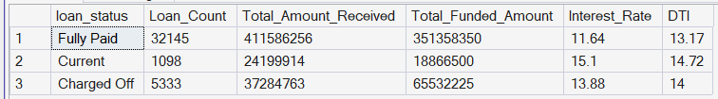

-- MTD Amount Grid View
select loan_status,
COUNT(id) as Loan_Count,
SUM(loan_amount) as MTD_total_funded_amount,
sum(total_payment) as MTD_total_received_amount
from bank_loan_data
where month(issue_date) = 12 and year(issue_date) = 2021
group by loan_status;

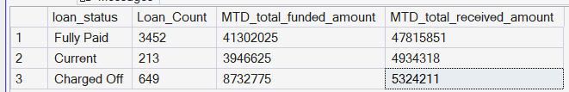

-- Monthly Trends by Issue Date
select
MONTH(issue_date) as Month_Number,
DATENAME(MONTH, issue_date) as Month_Name,
COUNT(id) as Total_Loan_Applications,
SUM(loan_amount) as Total_Funded_Amount,
SUM(total_payment) as Total_Received_Amount
from bank_loan_data
group by DATENAME(MONTH, issue_date), MONTH(issue_date)
order by MONTH(issue_date) asc
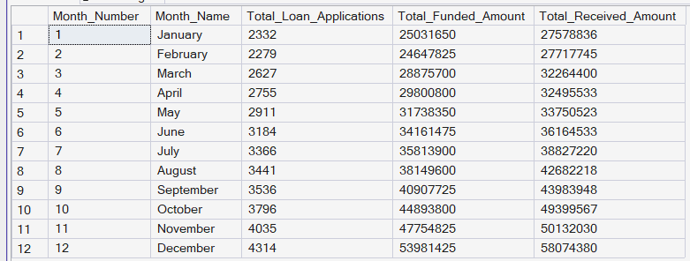
-- Regional Analysis by State
select
address_state as Country_State,
COUNT(id) as Total_Loan_Applications,
SUM(loan_amount) as Total_Funded_Amount,
SUM(total_payment) as Total_Received_Amount
from bank_loan_data
group by address_state
order by address_state asc
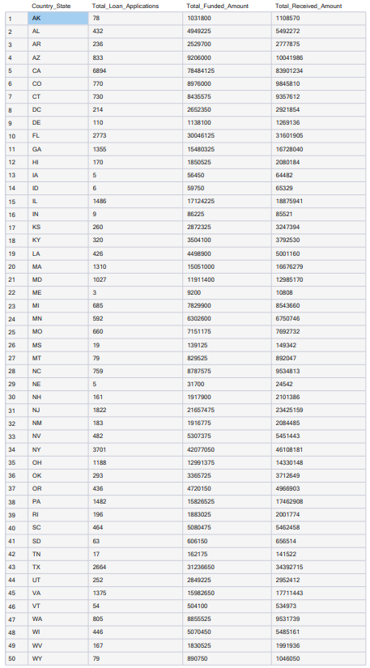
-- Loan Term Analysis
select
term as Loan_Term,
COUNT(id) as Total_Loan_Applications,
SUM(loan_amount) as Total_Funded_Amount,
SUM(total_payment) as Total_Received_Amount
from bank_loan_data
group by term
order by term asc
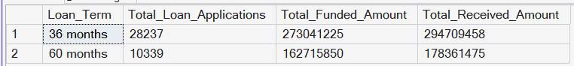

-- Employee Length Analysis
select
emp_length,
COUNT(id) as Total_Loan_Applications,
SUM(loan_amount) as Total_Funded_Amount,
SUM(total_payment) as Total_Received_Amount
from bank_loan_data
group by emp_length
order by emp_length asc
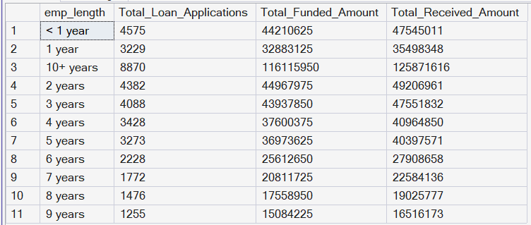

-- Loan Purpose Breakdown
select
purpose,
COUNT(id) as Total_Loan_Applications,
SUM(loan_amount) as Total_Funded_Amount,
SUM(total_payment) as Total_Received_Amount
from bank_loan_data
group by purpose
order by Total_Loan_Applications desc
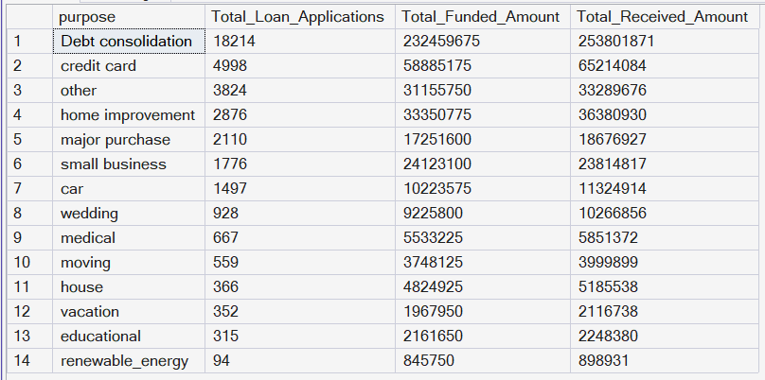
-- Home Ownership Analysis
select
home_ownership,
COUNT(id) as Total_Loan_Applications,
SUM(loan_amount) as Total_Funded_Amount,
SUM(total_payment) as Total_Received_Amount
from bank_loan_data
group by home_ownership
order by Total_Loan_Applications desc
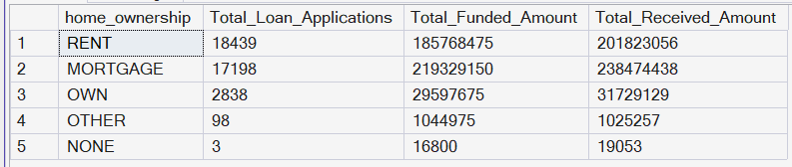

-- KPI Query
SELECT
COUNT(*) AS Total_Loan_Applications,
SUM(loan_amount) AS Total_Funded_Amount,
SUM(total_payment) AS Total_Received_Amount,
ROUND(AVG(int_rate) * 100, 2) AS Avg_Interest_Rate,
ROUND(AVG(dti) * 100, 2) AS Avg_DTI,
CAST(
COUNT(CASE WHEN loan_status IN ('Fully Paid','Current') THEN 1 END)
* 100.0 / COUNT(*) AS DECIMAL(5,2)
) AS Good_Loan_Percentage
FROM bank_loan_data;

